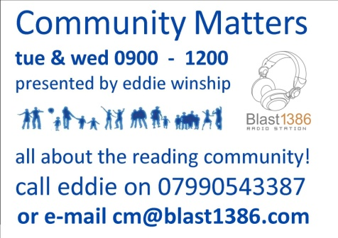

Date/Time | Name |  | Organisation
Phone | E-mail
Activities of Organisation

Topics for discussion:

Would you like to bring any other guests with you? Please give names below. |  | Do you have any particular music tastes? You can bring some of your own CDs.

