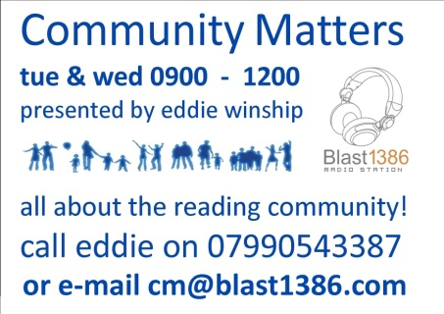
Hi
Thanks for agreeing to be interviewed on Community Matters. Can you be at Reception on the King’s Road Campus of Reading College, Kings Rd, Reading, Berkshire, RG1 4HJ. about 10 minutes before the time above. You will be met at Reception.
Parking is very limited so if you want to come by car, can you let me know and I will arrange a parking slot.
Your contacts can listen on www.blast1386.com or on 1386 AM. All shows are now being uploaded to Mixcloud at the end of each week, so you and others will be able to listen later on http://www.mixcloud.com/Communitymatters/.
Can I also ask you to complete the attached form, save it, then return it to me. You are very welcome to bring someone with you but I need to know in advance.
If you need more info, please feel free to call me on 07990543387
Look forward to seeing you.
Eddie

